



Firmware Update Instruction Manual

This manual guides you through downloading the latest LW-Z5010 Series firmware from Epson website, and updating the firmware of your LW-Z5010 Series.
Important!
- Settings is erased due to the update.
- During the update, be sure to use the AC adapter to supply the power to the printer instead of using the lithium-ion battery.

- Preparation

Check if your LW-Z5010 Series needs firmware update
Follow the procedure below to check whether your LW-Z5010 Series needs firmware update or not.
The firmware update is not necessary if the version is the latest one.

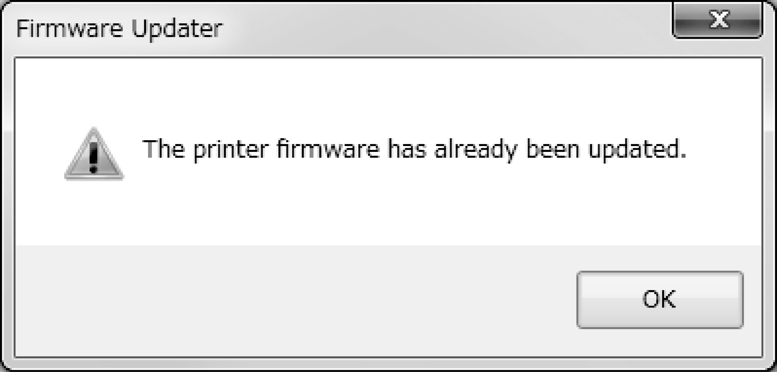
MEMO
You can know the need to update your LW-Z5010 Series firmware after you start the update. If the firmware is the latest one, a pop-up window shown right appears to notify you that the update is not needed.

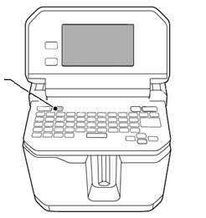
key
How to check
- Press .
Menu screen appears.

- Select the [Settings] menu to check the firmware version.
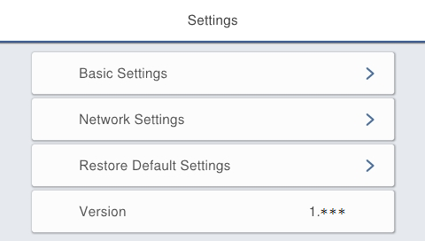
If the version is 1.04A or lower,
the firmware is old and needs to be updated.

Check the OS version of your computer
Make sure your OS version is one of the following.
- Windows 7 (32bit/64bit)
- Windows 8 (32bit/64bit)
- Windows 8.1 (32bit/64bit)
- Windows 10 (32bit/64bit)
- Windows 11 (64bit)

Download the Firmware Updater
Download “UpdaterLWZ5010V105A.exe” from Epson website, and save it to your desktop.
https://labelworks.epson.com/epson-labelworks-lw-z5010px-firmware.

- Firmware Update Procedure
Follow the procedure below to update the firmware of your LW-Z5010 Series.

- Put the LW-Z5010 Series into “update” mode
Press and hold  and , then press  to turn on the printer in the “update” mode.
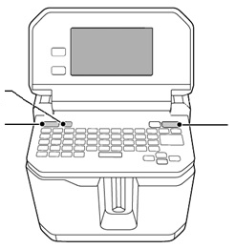
key
key
key

How to confirm that the printer has entered in the update mode
A title “Firmware Update” appears when the printer is in the update mode.
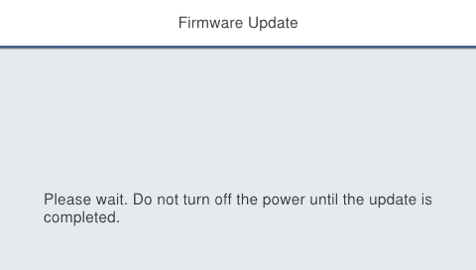

- Update the firmware

CAUTION
- Only one printer can be updated at a time. Do not connect two or more printers to the computer via USB.
- During the update, do not turn the printer off or disconnect the USB cable.

- Connect the printer to the computer with a USB cable.
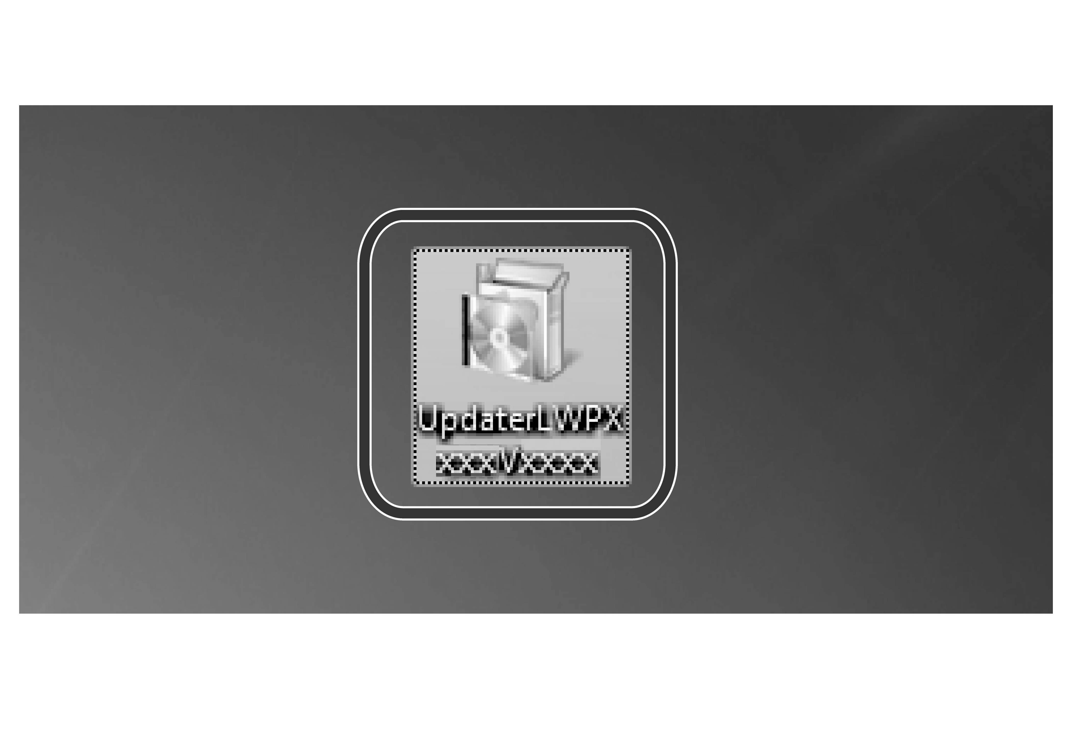
- Double-click “UpdaterLWZ5010V105A.exe” you previously saved to your desktop.
>> Download the Firmware Updater

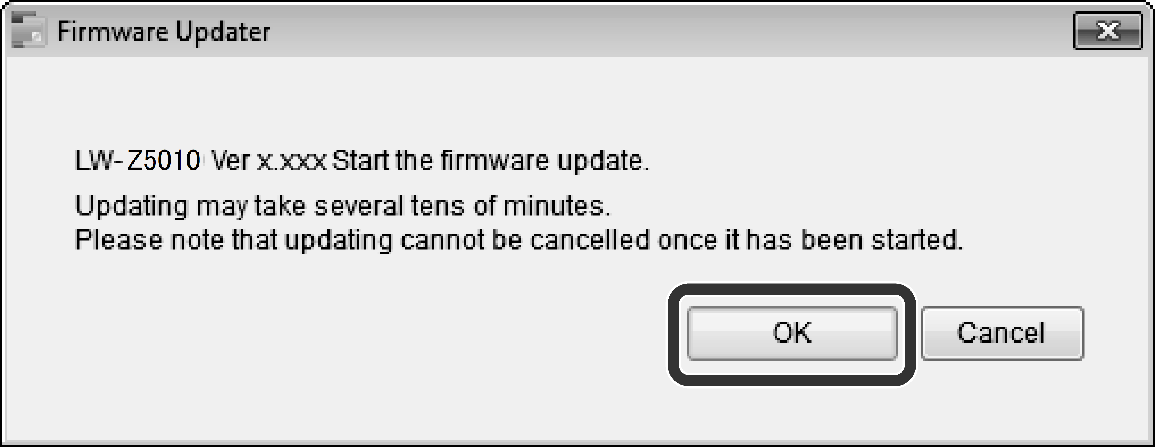
- Click [OK].
Firmware update is started.

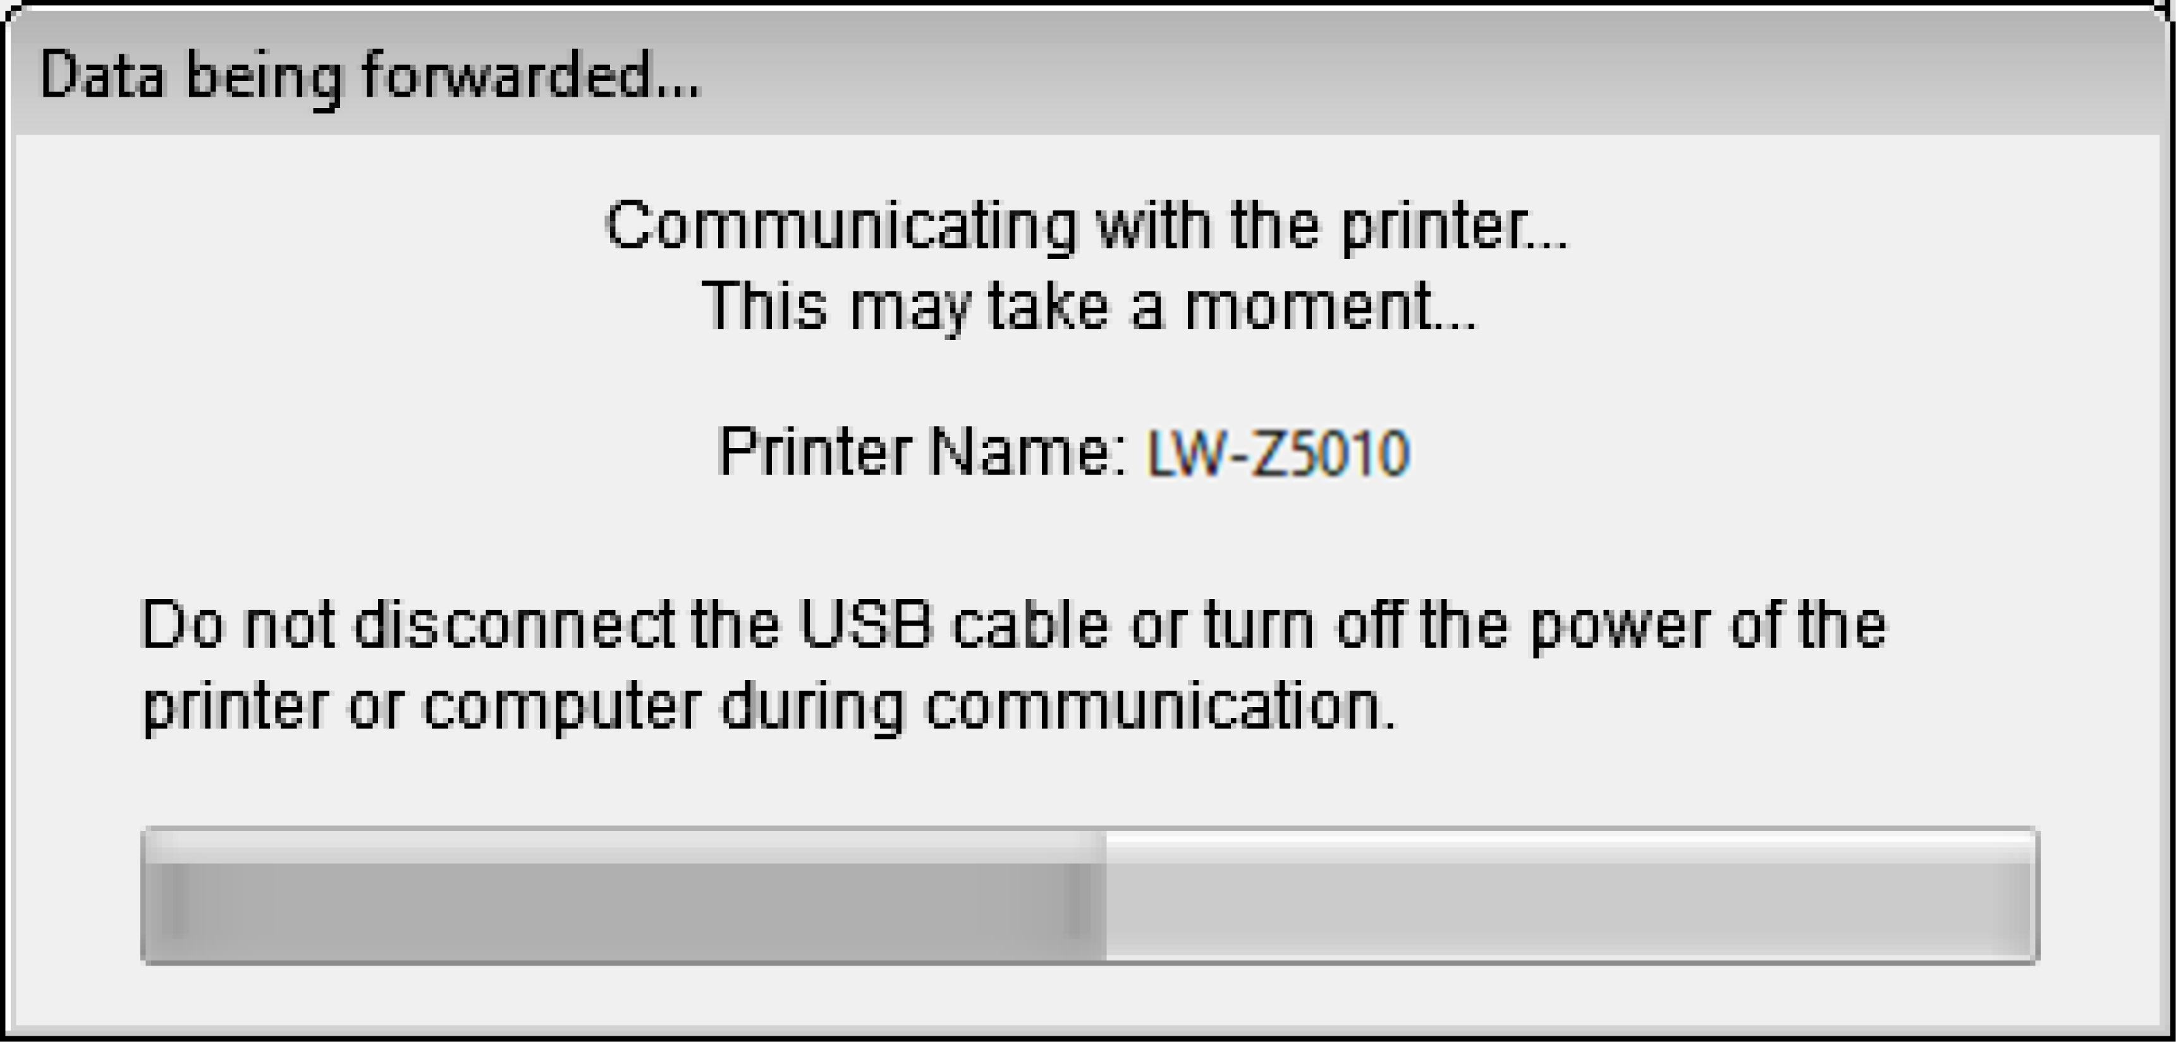
- A screen to show that the update is in progress is displayed during the update.
It takes about 5 to 10 minutes to complete the update, however, it may take longer depending on the computer environment.

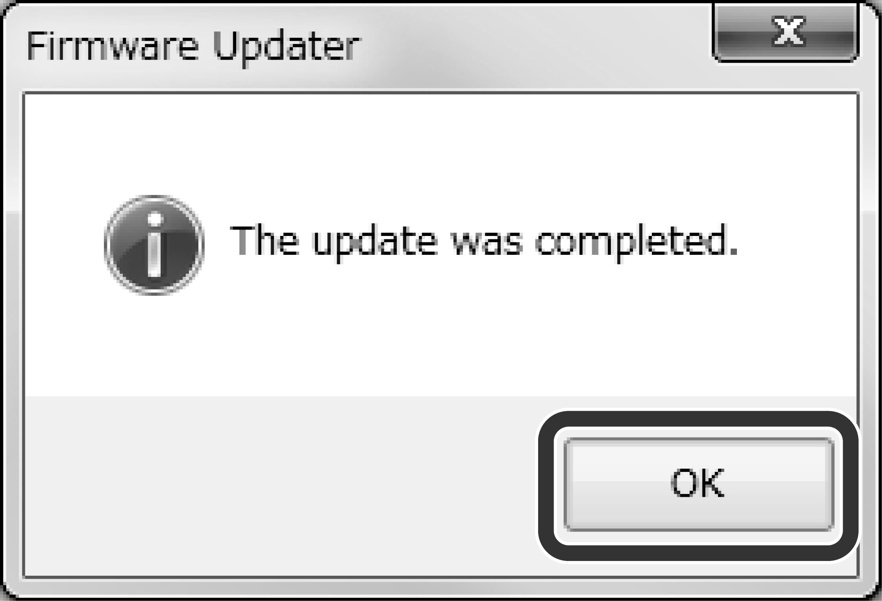
- Click [OK].

The firmware update is now complete.
You can use the printer immediately after completion of the update.

How to confirm if the update was completed successfully
- Disconnect the USB cable from the printer.
key
- Press .
Menu screen appears.

- Select [Settings]. The firmware version is displayed.
If the version is “1.05A”, the update has successfully completed.

Troubleshoot Update Errors

Error Messages | Troubleshooting
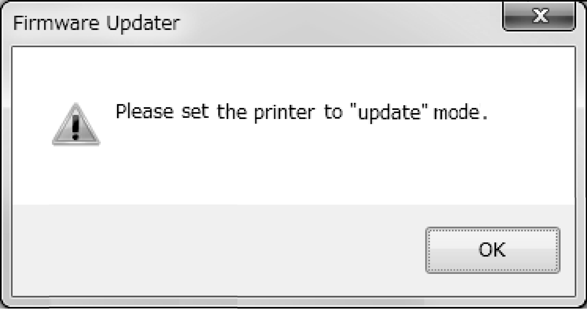 | Check if the printer is in the “update” mode.  >> Put the LW-Z5010 Series into “update” mode
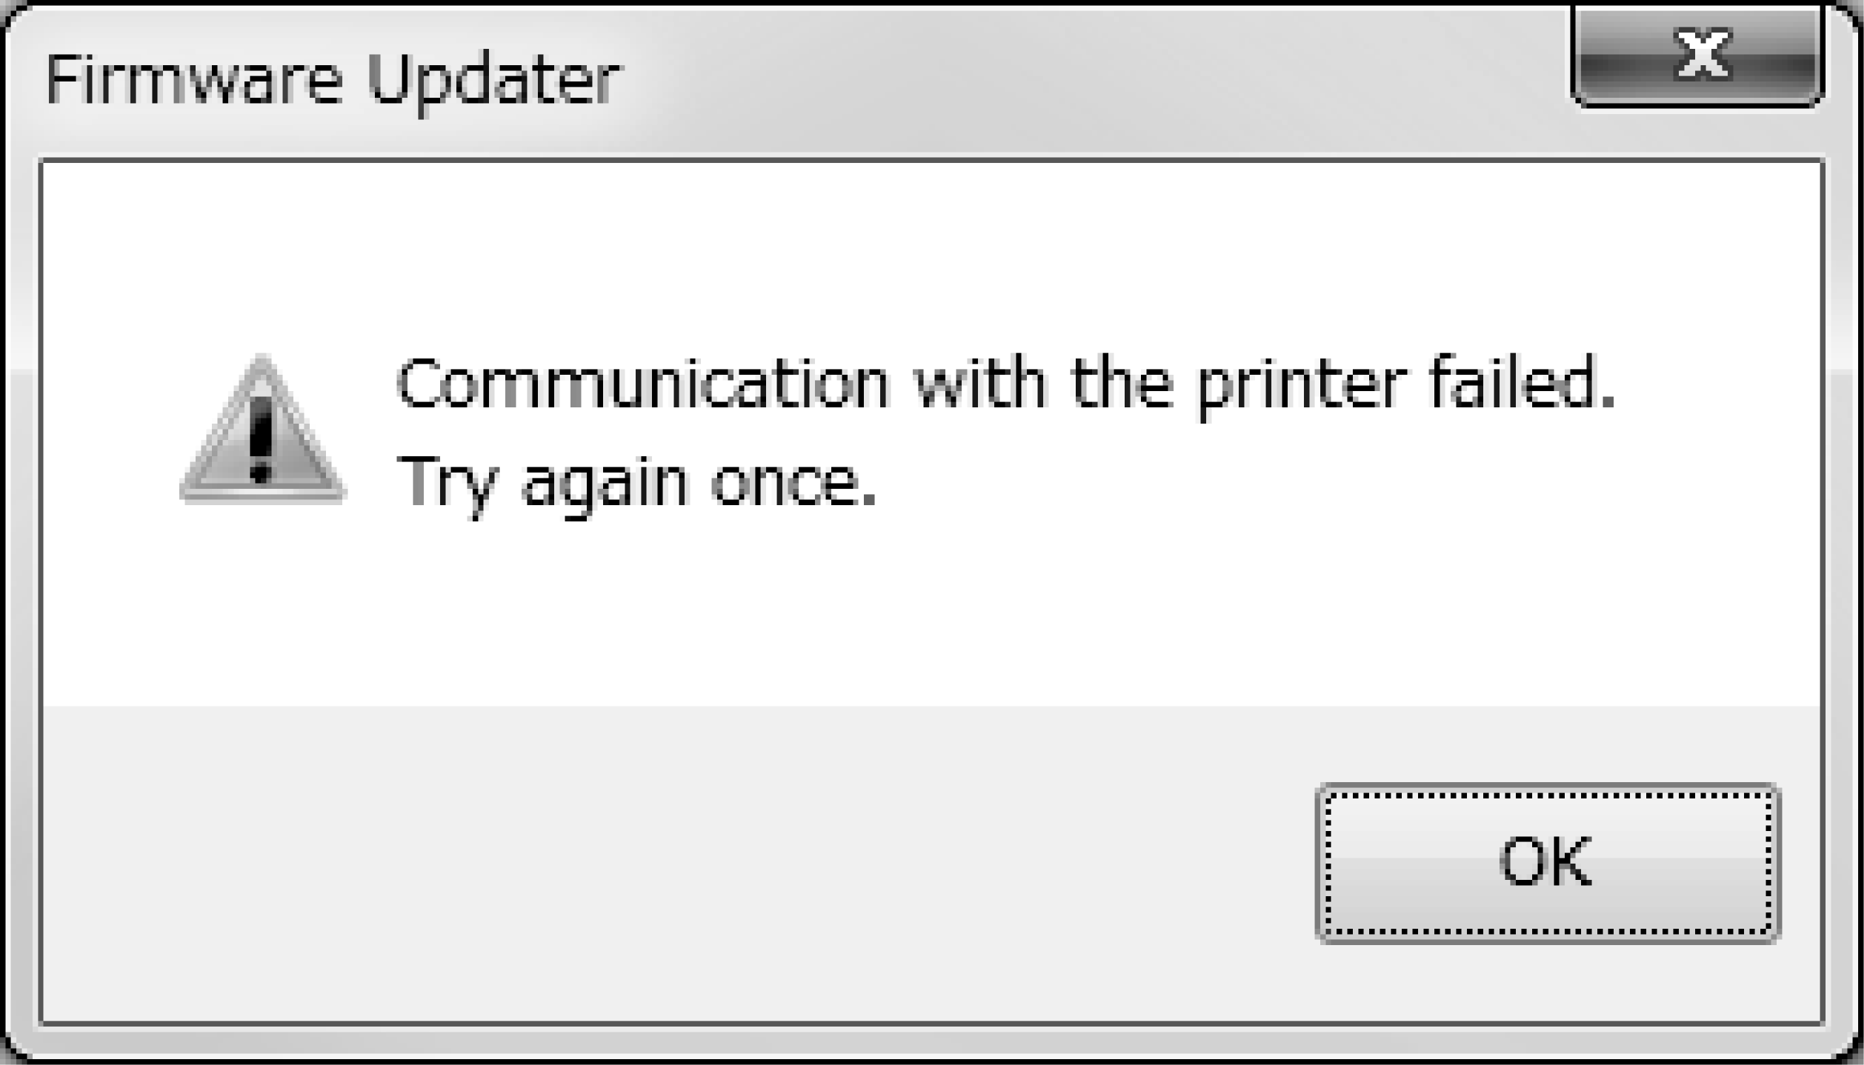 | Check if the USB cable is firmly connected to the printer and the computer. Then retry the update.  >> Update the firmware
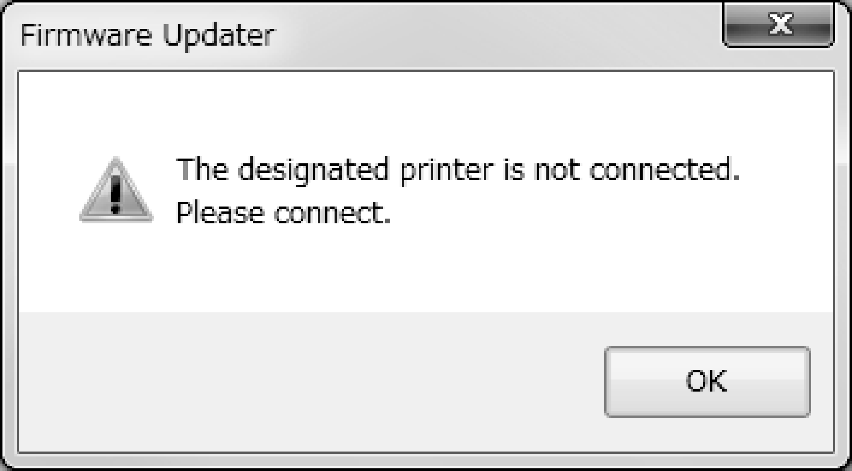 | LW-Z5010 Series is not connected. Put your LW-Z5010 Series into “update” mode, and then connect it to the computer.

